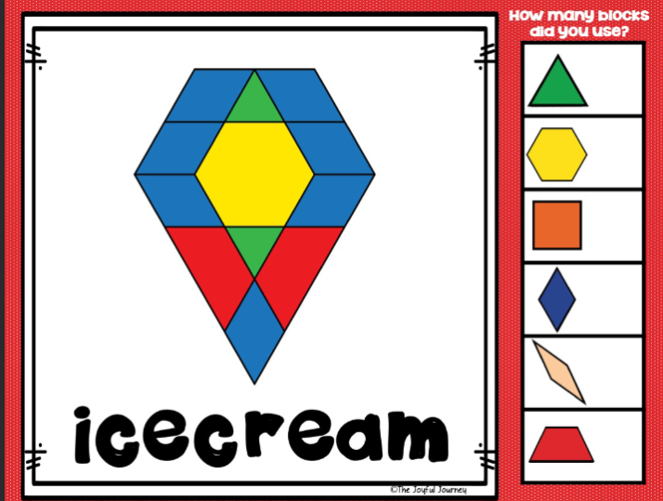

your

I

said

said

said

said

said

said

said

said

was

was

was

one

you

you

I

I