Build the picture with the matching pattern blocks.

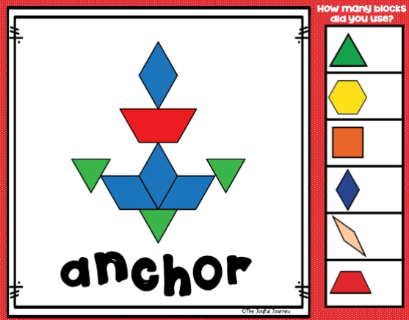
green
red
blue

green
blue
red

