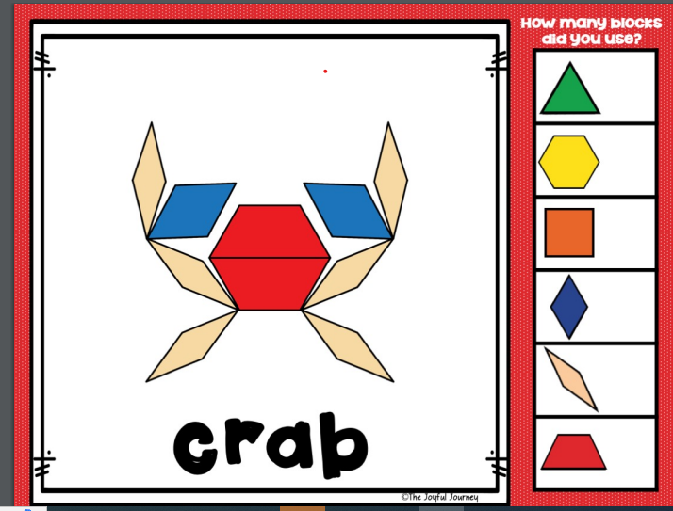

or

he

me

she

we

we

we

we

we

we

we

be

she

she

be

be