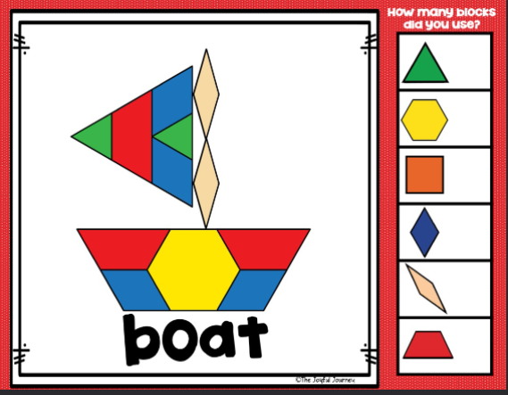

his

a

is

of

the

and

a

of

the

and

is