one

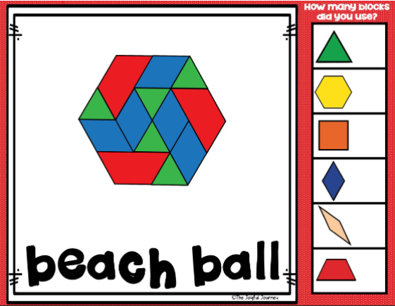

three

three

one

two

one

two

one

two